VIRGINIA ASSOCIATION OF CHIEFS OF POLICE
880 Technology Park Drive, Suite 100
Glen Allen, Virginia 23059
Phone: 804-285-8227
Fax: 804-285-3363
www.vachiefs.org
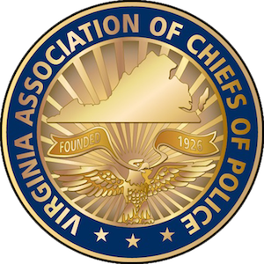
Contacts:  Ms. Dana Schrad, Executive Director  Mobile: (804) 338-9512; dana@vachiefs.org | Ms. Erin Schrad, Communications Manager  Mobile: (804) 512-5162; erin@vachiefs.org

2017 Virginia Law Enforcement Challenge Awards Announced

For Best Traffic Safety Programs in Virginia in 2016

The Virginia Association of Chiefs of Police (VACP) is pleased to announce the recipients of the 2017 Virginia Law Enforcement Challenge awards for the best traffic safety programs in the state in 2016. The awards luncheon took place during the VACP’s 92nd Annual Training Conference on Tuesday, September 19 at the Wyndham Oceanfront Hotel in Virginia Beach, VA.
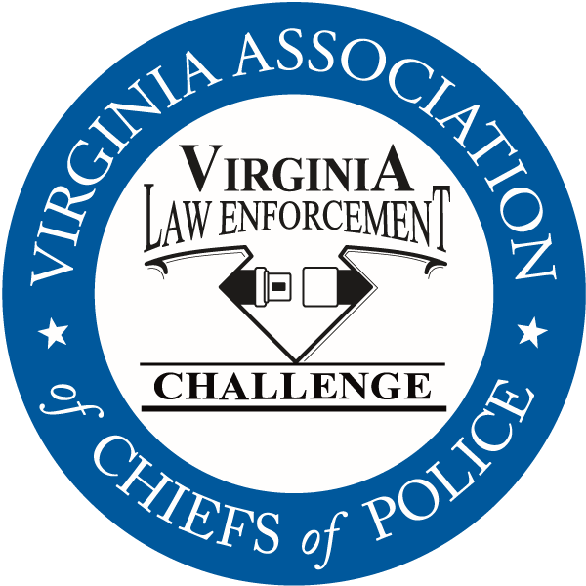
Celebrating its twenty-eighth year in Virginia, the Law Enforcement Challenge program promotes professionalism in traffic safety enforcement and encourages agencies to share best practices and programs with each other. The awards are based on entries prepared by the participating agencies that highlight their traffic safety education and enforcement activities in occupant protection, impaired driving and speed over the past calendar year. Judges award points to the agencies in the six areas that comprise a comprehensive traffic safety program: problem identification, policies, planning, training of officers, public information and education, enforcement, and an evaluation of the outcomes of the agency’s efforts.
The Virginia agencies listed below were presented with their first, second and third place state awards in each category at the awards luncheon, as well as special awards for outstanding enforcement and education efforts in the areas of occupant protection, impaired driving, speed awareness, commercial motor vehicle safety, distracted driving, technology, bicycle/pedestrian safety, and motorcycle safety.
Additionally, the VACP presented an award for the most outstanding traffic safety program in Virginia in 2016, regardless of agency size or type — the “Commonwealth Award”. This year, the Commonwealth Award goes to the Henrico County Division of Police.
Also presented at the Challenge Awards luncheon was an award from the National Sheriffs’ Association (NSA). The recipient of the 2016 NSA Traffic Safety Unit Award is the Hanover County Sheriff’s Office. Additional information about this award is available from the NSA at https://www.sheriffs.org/content/traffic-safety-unit-award
The Virginia Law Enforcement Challenge Awards program is supported by a grant from the Virginia Highway Safety Office. Additional information about the Law Enforcement Challenge program can be found online at http://www.smartsafeandsober.org/programs/LEC.
The Virginia Association of Chiefs of Police & Foundation is a statewide organization of federal, state and local police chiefs and law enforcement executives dedicated to improving the professionalism of police agencies in Virginia. The Association was founded in 1926 and has more than 600 members. For more information, visit http://www.vachiefs.org.

The winners of the 2017 Virginia Law Enforcement Challenge are as follows:
MUNICIPAL POLICE
Municipal 1: 1-25 Officers | Place
Ashland Police Department | 1
Bedford Police Department | 2
Municipal 2: 26-60 Officers | Place
Herndon Police Department | 1
Culpeper Police Department | 2
Colonial Heights Police Department | 3
Municipal 3: 61-125 Officers | Place
James City County Police Department | 1
Harrisonburg Police Department | 2
Salem Police Department | 3
Municipal 4: 126-225 Officers | Place
Lynchburg Police Department | 1
Roanoke County Police Department | 2
Albemarle County Police Department | 3
Municipal 5: 226-425 Officers | Place
Roanoke Police Department | 1
Chesapeake Police Department | 2
Municipal 6: 426-800 Officers | Place
Henrico County Division of Police | 1
Virginia Beach Police Department | 2
Municipal 7: 801 or More Officers | Place
Fairfax County Police Department | 1

SHERIFF’S OFFICES
Sheriff 1: 1-50 Deputies | Place
Westmoreland County Sheriff's Office | 1
New Kent County Sheriff's Office | 2
Sheriff 2: 51-125 Deputies | Place
Gloucester County Sheriff's Office | 1
Washington County Sheriff's Office | 2
Montgomery County Sheriff's Office | 3
Sheriff 3: 126 or More Deputies | Place
Stafford County Sheriff's Office | 1
Hanover County Sheriff's Office | 2
Fauquier County Sheriff's Office | 3

UNIVERSITY POLICE | Place
Virginia Commonwealth University Police Department | 1
University of Richmond Police Department | 2

SPECIAL LAW ENFORCEMENT | Place
Metro Washington Airports Authority Police Department | 1

SPECIAL AWARDS
Occupant Protection Award | James City County Police Department
Impaired Driving Award | Henrico County Division of Police
Speed Awareness Award | Stafford County Sheriff’s Office
Motorcycle Safety Award | Harrisonburg Police Department
Technology Award | Culpeper Police Department
Distracted Driving Award | Metro Washington Airports Authority Police Dept.
Bicycle/Pedestrian Safety Award | Salem Police Department
Commercial Motor Vehicle Safety Award | Harrisonburg Police Department
Traffic Incident Management | Fairfax County Police Department
“Commonwealth Award” for Best Overall Traffic Safety Program in Virginia | Henrico County Division of Police
National Sheriffs’ Association Top Traffic Unit Award | Hanover County Sheriff’s Office

