VIRGINIA ASSOCIATION OF CHIEFS OF POLICE
880 Technology Park Drive, Suite 100
Glen Allen, Virginia 23059
Phone: 804-285-8227
Fax: 804-285-3363
www.vachiefs.org
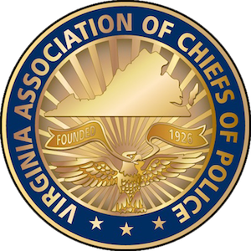
Contacts:  Ms. Dana Schrad, Executive Director  Mobile: (804) 338-9512; dana@vachiefs.org | Ms. Erin Schrad, Communications Manager  Mobile: (804) 512-5162; erin@vachiefs.org

2018 Virginia Law Enforcement Challenge Awards Announced

For Best Traffic Safety Programs in Virginia in 2017

The Virginia Association of Chiefs of Police (VACP) is pleased to announce the recipients of the 2018 Virginia Law Enforcement Challenge awards for the best traffic safety programs in the state in 2017. The awards luncheon took place during the VACP’s 93rd Annual Training Conference on Tuesday, September 11 at the Hotel Roanoke in Roanoke, VA.
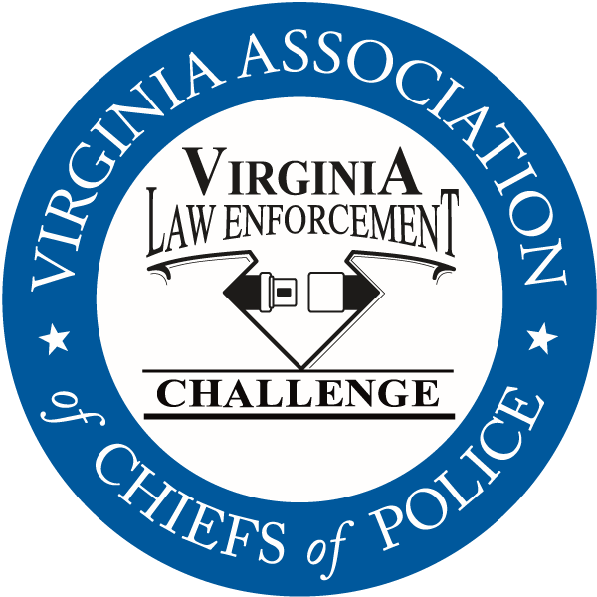
Celebrating its twenty-ninth year in Virginia, the Law Enforcement Challenge program promotes professionalism in traffic safety enforcement and encourages agencies to share best practices and programs with each other. The awards are based on entries prepared by the participating agencies that highlight their traffic safety education and enforcement activities in occupant protection, impaired driving and speed over the past calendar year. Judges award points to the agencies in the six areas that comprise a comprehensive traffic safety program: problem identification, policies, planning, training of officers, public information and education, enforcement, and an evaluation of the outcomes of the agency’s efforts.
The Virginia agencies listed below were presented with their first, second and third place state awards in each category at the awards luncheon, as well as special awards for outstanding enforcement and education efforts in the areas of occupant protection, impaired driving, speed awareness, commercial motor vehicle safety, distracted driving, technology, bicycle/pedestrian safety, motorcycle safety, and underage alcohol awareness.
Additionally, the VACP presented an award for the most outstanding traffic safety program in Virginia in 2017, regardless of agency size or type — the “Commonwealth Award”. The 2018 Commonwealth Award recipient is the Henrico County Police Division.
The Virginia Law Enforcement Challenge Awards program is supported by a grant from the Virginia Highway Safety Office. Additional information about the Law Enforcement Challenge program can be found online at http://www.smartsafeandsober.org/programs/LEC.
The Virginia Association of Chiefs of Police & Foundation is a statewide organization of federal, state and local police chiefs and law enforcement executives dedicated to improving the professionalism of police agencies in Virginia. The Association was founded in 1926 and has more than 600 members. For more information, visit http://www.vachiefs.org.

The winners of the 2018 Virginia Law Enforcement Challenge are as follows:
MUNICIPAL POLICE
Municipal 1: 1-25 Officers | Place
Ashland Police Department | 1
Bedford Police Department | 2
Municipal 2: 26-60 Officers | Place
Herndon Police Department | 1
Culpeper Police Department | 2
Colonial Heights Police Department | 3
Municipal 3: 61-125 Officers | Place
Harrisonburg Police Department | 1
Salem Police Department | 2
Municipal 4: 126-225 Officers | Place
Roanoke County Police Department | 1
Albemarle County Police Department | 2
Lynchburg Police Department | 3
Municipal 5: 226-375 Officers | Place
Alexandria Police Department | 1
Roanoke Police Department | 2
Suffolk Police Department | 3
Municipal 6: 376-700 Officers | Place
Henrico County Police Division | 1
Chesapeake Police Department | 2
Municipal 7: 701 or More Officers | Place
Virginia Beach Police Department | 1 (tie)
Fairfax County Police Department | 1 (tie)
Richmond Police Department | 2

SHERIFF’S OFFICES
Sheriff 1: 1-50 Deputies | Place
New Kent County Sheriff's Office | 1
Westmoreland County Sheriff's Office | 2
Sheriff 2: 51-150 Deputies | Place
Gloucester County Sheriff's Office | 1 (tie)
Montgomery County Sheriff's Office | 1 (tie)
Fauquier County Sheriff's Office | 2
Sheriff 3: 151 or More Deputies | Place
Stafford County Sheriff's Office | 1
Hanover County Sheriff's Office | 2

UNIVERSITY POLICE | Place
Virginia Commonwealth University Police Department | 1

SPECIAL LAW ENFORCEMENT | Place
Metro Washington Airports Authority Police Department | 1

SPECIAL AWARDS
Impaired Driving Award | Roanoke County Police Department
Occupant Protection Award | New Kent County Sheriff’s Office
Speed Awareness Award | Henrico County Police Division
Bicycle/Pedestrian Safety Award | Salem Police Department
Commercial Motor Vehicle Safety Award | Fairfax County Police Department
Distracted Driving Award | Virginia Beach Police Department
Motorcycle Safety Award | Harrisonburg Police Department
Technology Award | Culpeper Police Department
Traffic Incident Management | Ashland Police Department
Underage Alcohol Awareness Award | Harrisonburg Police Department
“Commonwealth Award” for Best Overall Traffic Safety Program in Virginia | Henrico County Police Division

