[Your agency’s or locality’s logo]

FOR IMMEDIATE RELEASE
May 5, 2014
Contact: Your agency’s contact person
Phone
Email address

Half of Virginia’s Road Deaths Avoidable With Belt, Restraint Use

Law Enforcement Out in Full Force During Click It or Ticket

Seat belts prevent ejection and without one, a person’s body becomes a missile inside the vehicle. [Local law enforcement agency or locality] along with DMV’s Virginia Highway Safety Office encourages everyone on the road to wear their seat belts during every trip, day and night.
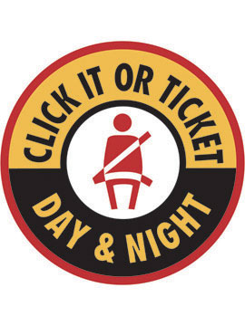
Law enforcement officers in [your locality] and across Virginia and the nation will be out in full force looking for seat belt violators during the national Click It or Ticket enforcement mobilization this May. “If you’re not buckled up, you will get a ticket,” warned [local law enforcement]. “Don’t risk death or injuring others in your vehicle. If you’re driving, the second action you need to take after fastening your own seat belt is to insist all your passengers are wearing their belts too.”
Day and night, local law enforcement officers are on the lookout for those not wearing their seat belts--and for good reason. In 2012 in the U.S., 61 percent of passenger vehicle occupants killed at night (6 p.m. – 5:59 a.m.) were not wearing their seat belts. “Local law enforcement officers are actually trained to spot seat belt violations at night, so just because it’s dark, don’t think they won’t be able to spot unbelted drivers,” said [local law enforcement.]
Virginia’s statewide seat belt use rate was 79.7 percent in 2013 and 78.4 percent in 2012. Last year in Virginia, 54 percent of all traffic fatalities, or 310 deaths, were unrestrained drivers and passengers. Also, 118 (38 percent) of the unrestrained deaths were young people ages 21 to 35, and 73 percent were males. Most of the unrestrained fatalities, 144 or 46 percent, occurred between the hours of 6 p.m. and 3 a.m. Of the 228 unbelted driver fatalities, 55 (24 percent) had been drinking.
Drivers (75.7 percent) and passengers (68.8 percent) in pickup trucks had the lowest seat belt use rates, along with passengers (69.4 percent) in work vans.
“These numbers tell us young males, many of them pickup drivers who’ve been drinking, are not buckling up and dying on our roadways,” said [local law enforcement]. “We want to do everything we can to reach these people and save their lives.”
Those who drive and ride in pickup trucks may think that their large vehicle will protect them more than other vehicles in a crash. This false sense of security may cause them to not wear their seat belts, but the stats show that this bravado is misplaced. “Everyone, no matter what vehicle they are in or if they are a driver or passenger, should always buckle up,” said [local law enforcement.]
###

