[Your agency’s or locality’s logo]

FOR IMMEDIATE RELEASE
May 4, 2015
Contact: Your agency’s contact person
Phone
Email address

Seat Belts Prevent Ejection, Save Lives
Safety Restraint Violations the Focus During Click It

Would you ever ride a roller coaster without the harness down? Would you ever skydive without a parachute? When you ride in a motor vehicle without a seat belt, you are taking the same huge risk.
Seat belts are the single most effective traffic safety device for preventing death during a crash. Seat belts are the best defense against impaired, aggressive and distracted drivers. [Local spokesperson] along with DMV’s Virginia Highway Safety Office encourages everyone on the road to wear their seat belts during every trip, day and night.
Virginia law requires all front seat occupants of motor vehicles be restrained, and any passenger from birth to 18 years old be properly restrained in an appropriate child safety seat or seat belt. Virginia law also requires that rear-facing child restraint devices be placed in the back seat of a vehicle. “It’s the law in Virginia to wear your seat belt and make sure children are in a car seat, and doing so will save your life during a crash,” said [local spokesperson].
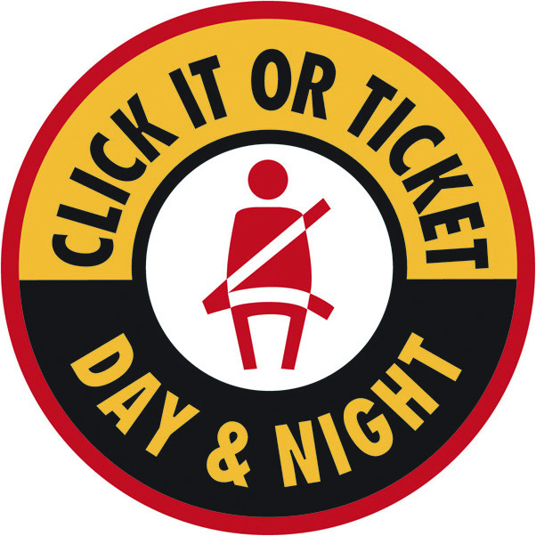
Law enforcement officers across Virginia and the nation will be out in full force during the national Click It or Ticket enforcement mobilization, May 18 through May 31, looking for seat belt violators. “Not only do you risk getting a ticket, but by not wearing your seat belt, you risk severe injury and even death,” said [local spokesperson.]
Virginia’s statewide seat belt use rate was 77.3 percent in 2014, 79.7 percent in 2013 and 78.4 percent in 2012. Last year in Virginia, 52 percent of all traffic fatalities, or 256 deaths, were unrestrained drivers and passengers. Also, 154 (60 percent) of the unrestrained deaths were people ages 21 to 50, and 65 percent were males. Of the 198 unbelted driver fatalities, 40 (20 percent) had been drinking. Almost half of the unrestrained fatalities in 2014 occurred at night, between 6 p.m. and 3 a.m.
“These numbers tell us that young males, many of them drinking and driving, are not wearing seat belts and are dying on our roadways,” said [local spokesperson]. “We want to do everything we can to reach these people and save their lives.”
According to the National Highway Traffic Safety Administration, seat belts really do save lives. From 2008 to 2012, they saved nearly 63,000 lives nationwide. And in 2012 in the United States, an additional 3,031 lives could have been saved if all unrestrained occupants involved in fatal crashes had worn their seat belts.
###

