[Your agency’s or locality’s logo]

FOR IMMEDIATE RELEASE
May X, 2016
Contact: Your agency’s contact person
Phone
Email address

Click It or Ticket Effort Occurs Before High-Traffic Holiday
More Enforcement, Awareness Focus of Annual Mobilization

From May 23 to June 5, 2016, Virginia’s local law enforcement and Virginia State Police will participate in the national Click It or Ticket campaign in an effort to save lives through increased seat belt use. This enforcement period is in advance of and includes the Memorial Day holiday, one of the busiest travel weekends of the year.

There were 310 unrestrained fatalities in Virginia last year, and 71 were recorded so far this year, between Jan. 1 and March 31, 2016. Nationally, 88.5 percent of passenger vehicle occupants buckled up last year, according the National Highway Traffic Safety Administration (NHTSA), but almost 50 percent of fatal crash occupants were not restrained. In some states, the rate was as high as 70 percent unrestrained in fatal crashes. “This fact gravely highlights the need for increased enforcement and awareness of seat belt use,” said [Local Law Enforcement Official].

“Time after time, we see the deadly results that come from drivers and passengers refusing to wear a seat belt,” Official said. “Wearing a seat belt is one of the most important steps in increasing survivability in a crash. Our job is to stop those who are not buckled up, and to keep them from repeating this potentially deadly mistake.”
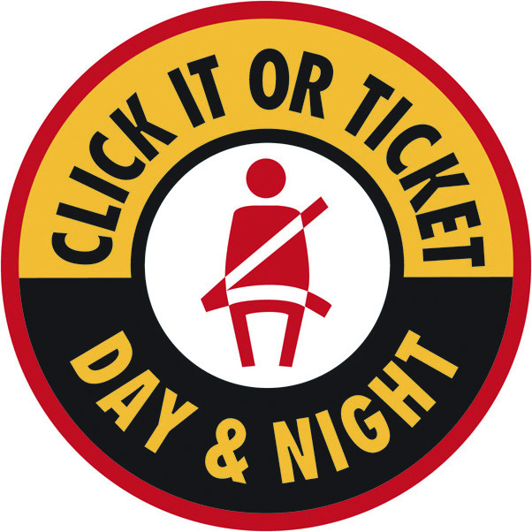
Virginia’s statewide seat belt use rate was 80.9 percent in 2015, 77.3 percent in 2014, 79.7 percent in 2013 and 78.4 percent in 2012. The 310 unrestrained fatalities in Virginia last year represent 41 percent of the 753 total traffic fatalities.

“The numbers tell us that young males, many of them drinking and driving, are the ones not wearing seat belts and are dying on our roadways,” said [Local Law Enforcement Official]. “We want to do everything we can to reach these people and save their lives.”

According to NHTSA, there were 9,385 unbuckled passenger vehicle occupants killed in crashes in 2014 in the United States. Also in 2014, seat belts saved an estimated 12,802 people from dying nationwide. From 2010 to 2014 seat belts saved nearly 63,000 lives. If all passenger vehicle occupants age 5 and older involved in fatal crashes had worn their seat belts, an additional 2,814 lives could have been saved in 2014 alone.
###

